МИНИСТЕРСТВО ОБРАЗОВАНИЯ И НАУКИ

РОССИЙСКОЙ ФЕДЕРАЦИИ

ФЕДЕРАЛЬНОЕ ГОСУДАРСТВЕННОЕ АВТОНОМНОЕ ОБРАЗОВАТЕЛЬНОЕ УЧРЕЖДЕНИЕ ВЫСШЕГО ОБРАЗОВАНИЯ

«САМАРСКИЙ НАЦИОНАЛЬНЫЙ ИССЛЕДОВАТЕЛЬСКИЙ

УНИВЕРСИТЕТ ИМЕНИ АКАДЕМИКА С.П. КОРОЛЕВА»

Институт информатики и кибернетики

Факультет информатики

Кафедра геоинформатики и информационной безопасности

Отчёт по лабораторной работе №1

«VM and RAID»

Выполнила: Чекушкина В.А.

Группа: 6412-100503D

Проверил: Авдеев Е.В.

Самара 2023

**TASK**

Steps:

1. Create virtual machine with debian/ubuntu/centos or download preinstalled image (<https://www.osboxes.org/>). It should be withoug GUI.
2. Set hostname = your surname.
3. Add simple raid1 to virtual machine: *nix os system on 1-st hdd, 2d and 3d hdds are in raid1. 1 (with star). Only two hdds. Os system on raid1, based on this two hdd.
4. How to test raid1. Create file on raid1 file system. Turn off vm and remove one of the hhds from vm. Turn on vm. File should be accessible.
5. Add new hdd and sync it to raid1.
6. Install and run local Kubernetes cluster with **minikube.**

****PROCESS OF WORK****

1. Install an Ubuntu Server virtual machine using Virtual Box and add two additional HDDs.

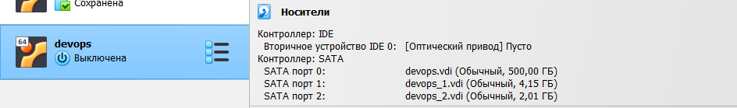

1. **Set hostname chekushkina**

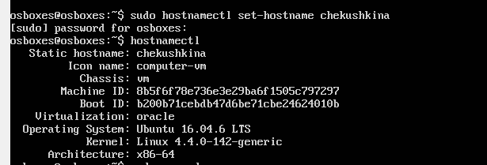

1. Create RAID1 based on sdb and sdc.

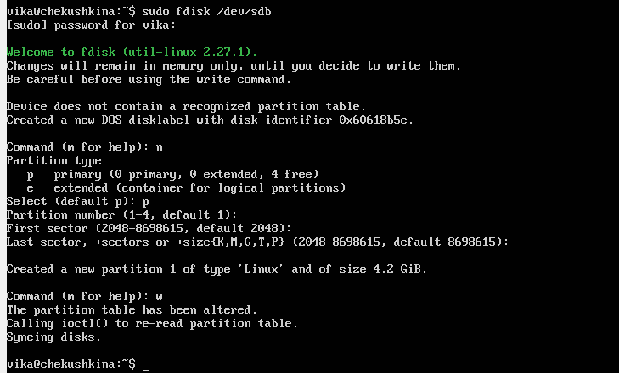

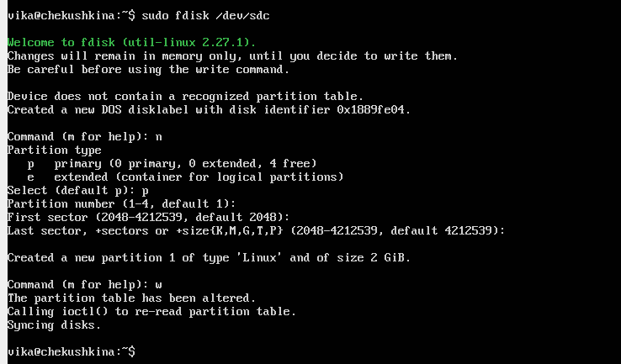

Let's check the success of the creation using the lsblk command:

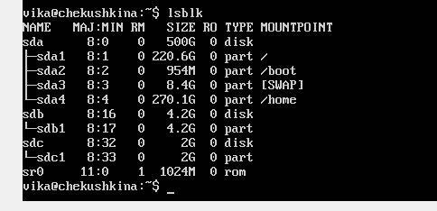

Create a RAID 1 array in /dev/md0 using the mdadm command:

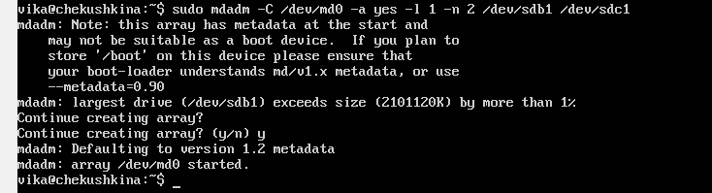

Result of creation:

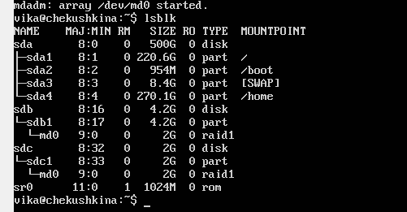

1. Create file system:

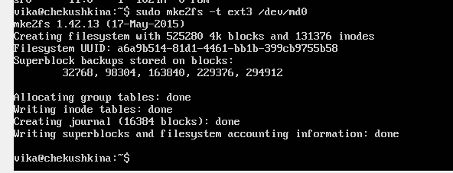

To mount the file system, use the following command:

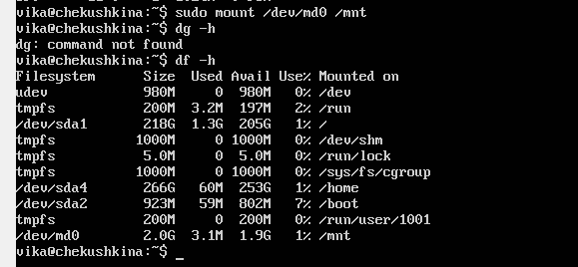

Save the created partitions to mount them automatically each time the system boots.

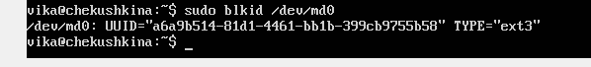

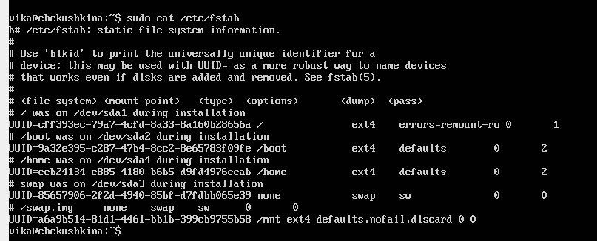

Let's see the result after our actions:

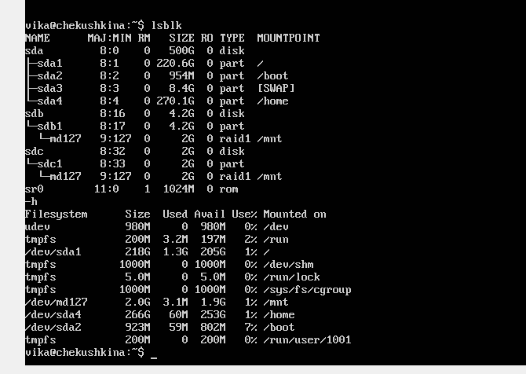

The next step is to create a text file lab1.txt using the touch command and open a text editor with the nano command to write information to the file.

Use the cat command to view the contents of the file:

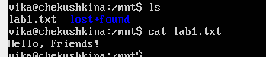

Test raid1. Remove sdc1 from raid1, check if the file remains after remove:

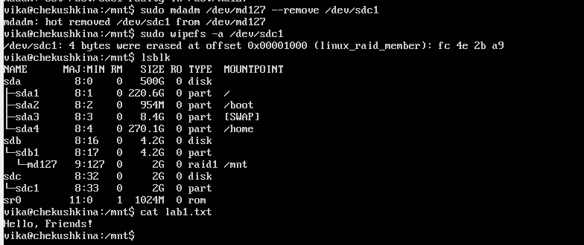

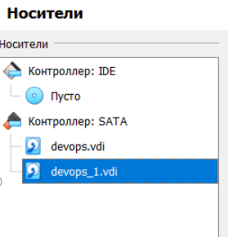

1. **Let's add a new hard drive and synchronize it with raid 1 in the same way.**

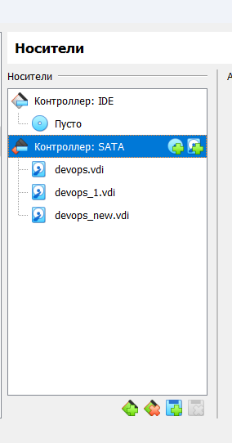

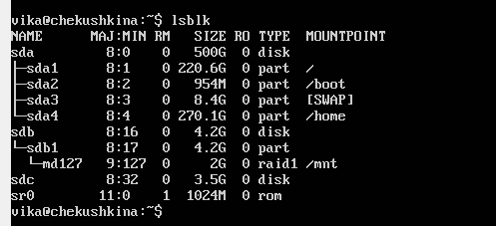

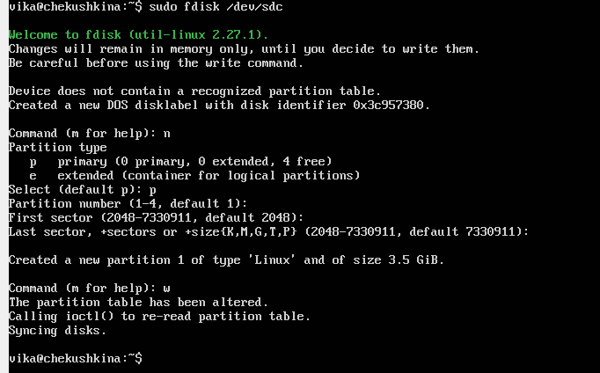

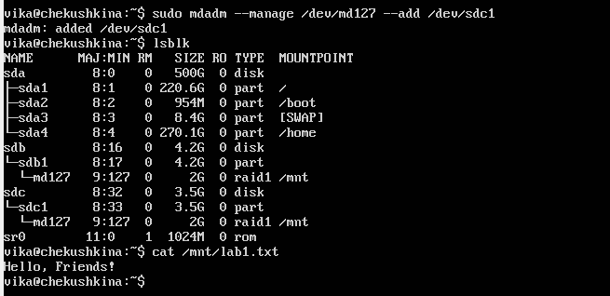

1. **I**nstall and run local Kubernetes cluster with **minikube.**

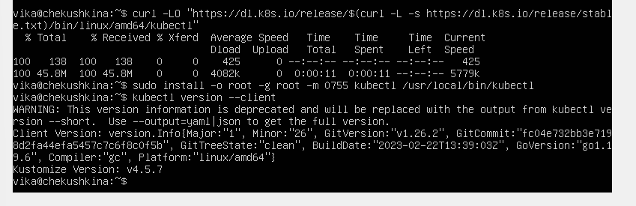

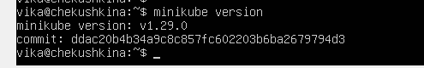

Opened Dashboard in web-browser:

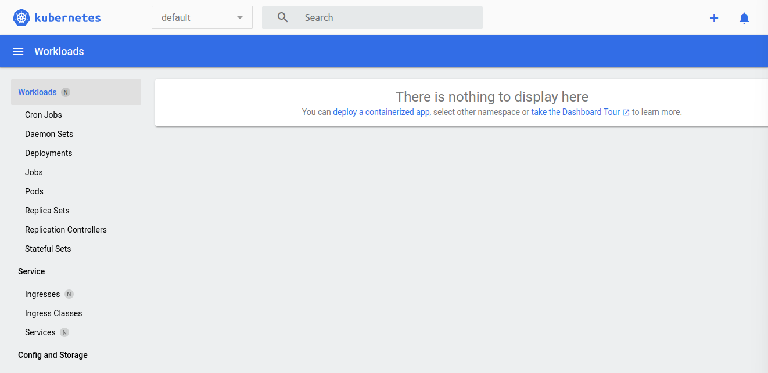

Hello-minicube app in web-browser:

